UNIVERSITY OF INFORMATION TECHNOLOGY

FACULTY OF COMPUTER NETWORK AND COMMUNICATION

**REPORT**

Subject: Cryptography

Semester I (2024 – 2025)

**Report Lab 4**

Nhóm :13

Student: Võ Hoài Nam

Student ID Number: 23520990

Student: Nguyễn Huỳnh Nhân

Student ID Number: 23521080

Class: NT219.P22.ANTT

University of Information Technology

Report Lab 4

**Student Information**

Full Name: Nguyễn Huỳnh Nhân

Student ID Number: 23520180

Class: ATTT2023.2

Full Name: Võ Hoài Nam

Student ID Number: 23520990

Class: ATTT2023.2

**Device Information**

CPU: 11th Gen Intel(R) Core(TM) i5-1135G7

Ram: 16 GB DDR4 3200MHz

SSD PCle: 512GB

1. Task1

1MB

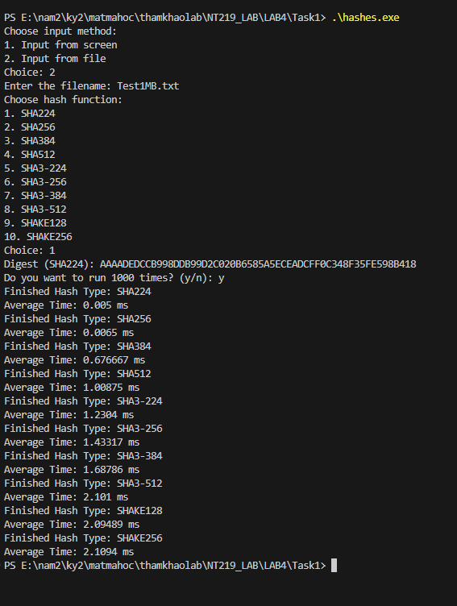

25 MB

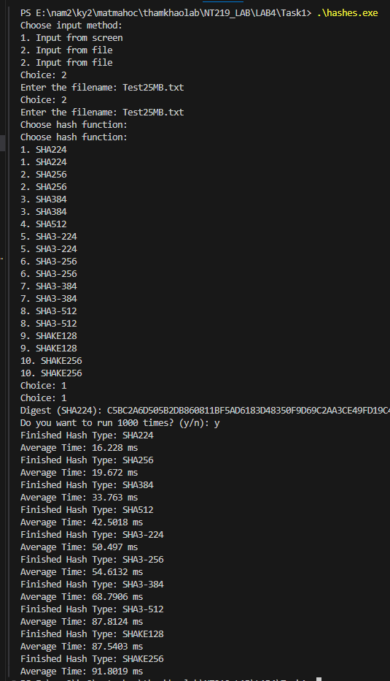

100MB

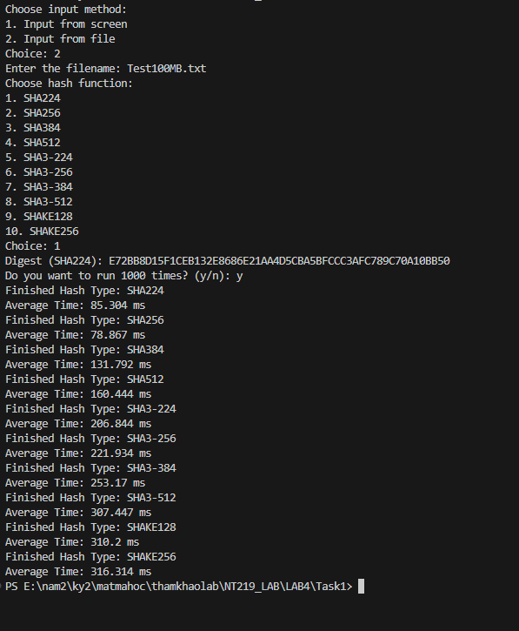

Test 300Mb

Test 1Gb

Unbutu

Test 1MB

Test 25MB

Test 100MB

Test 300 MB

Test 1GB

